DBMS Hashing Cheatsheet

1. Basics of Hashing
- Hash Function h(k) → Maps key k to a bucket number for storage.
- Lookup/Insert: Compute h(k) → Find bucket → Insert/Retrieve record.
- Overflow Handling: If bucket full → Create overflow block.
Pros: Fast equality lookups (WHERE key = x).
Cons: Poor for range queries.

2. Types of Hashing
Feature | Simple | Extensible | Linear
Bucket Growth | Fixed | Dynamic (doubles) | Dynamic (linear)
Overflow Blocks | Yes | No | Yes
Bit Use | Fixed | MSB (leftmost) bits | LSB (rightmost) bits
Indirection | None | Directory required | None

3. Extensible Hashing
- Uses directory pointing to buckets.
- Directory size = 2^i (power of 2, based on i bits of h(k)).
- Insertion Rules:
  - Use i leftmost bits to choose bucket.
  - If bucket is full, split bucket and increase local depth k.
  - If k > i, double directory size, then split.
  - No overflow blocks → Recursive splitting possible.
Lookup Cost:
- 1 disk I/O (bucket) + possible 1 I/O for directory (if on disk).

4. Linear Hashing
- No directory → Buckets numbered linearly.
- Uses i rightmost bits of h(k).
- Controlled by utilization factor (UF), e.g., 85%.
Insertion Steps:
- Compute m = h(k) mod 2^i.
- If m < n (current number of buckets) → Insert in bucket m.
- If m ≥ n → Change MSB of m to 0 → Insert there.
- If UF exceeded → add new bucket + rearrange records if needed.
- Overflow blocks allowed if not splitting immediately.
Rearrangement Rule:
If bucket 011 is split → Create 111; move records ending with those bits.

5. Utilization Factor

Example:
If 2 records per bucket and UF = 85%,
For 100 records → ceil(100 / (2 * 0.85)) = 59 buckets.

6. Key Differences
Feature | Extensible | Linear
Bit Side | MSB (leftmost) | LSB (rightmost)
Splitting | Recursive, as needed | Incremental, linear
Overflow Blocks | None | Possible
Lookup IOs | ≤ 2 (with directory) | ≥ 1 (more with overflows)

7. Recursive Splitting Probability (Extensible)
- Recursive split happens if all records in a full bucket share next bit.
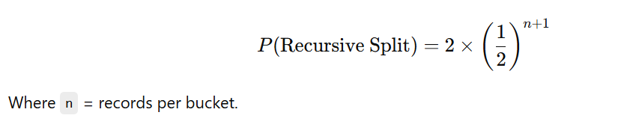

8. External Pointer Handling
If external pointers prevent record movement:
- Leave forwarding addresses on split.
- Use full hash value as pointer; resolve via hash table lookup.

